For my last post of the year, I’ll do an update of the simple but useful Find Orphaned Files app. If you are not familiar with the app, it was developed by Jan Liska and is an easy way to find files that have no parent files.
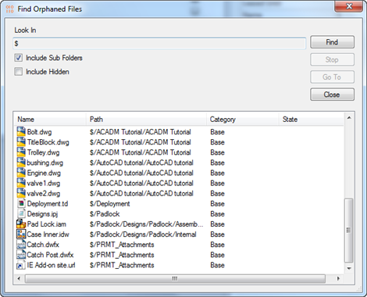
Requirements:
Vault Workgroup or Professional 2014
Click here to download the application
Click here to download the source code
Click here for the 2013 version
As with all the samples on this site, the legal disclaimer applies.

